Bonus MS_客製化贈點

步驟 1：營運後台調整活動持久化門檻
使用 Postman 呼叫行銷控制層 API，將 702 活動專案的門檻金額持久化修改為 50000 元;
PUT
http://localhost:8095/Surrounding/api/bonus/Marketing/updateProject
JOSN
{
"lrq01": "702",
"lrq02": "702",
"lrqplant": "A101",
"lrq03": 50000,
"lrqacti": "Y",
"lrq10": "2026-05-01",
"lrq11": "2026-06-03"
}
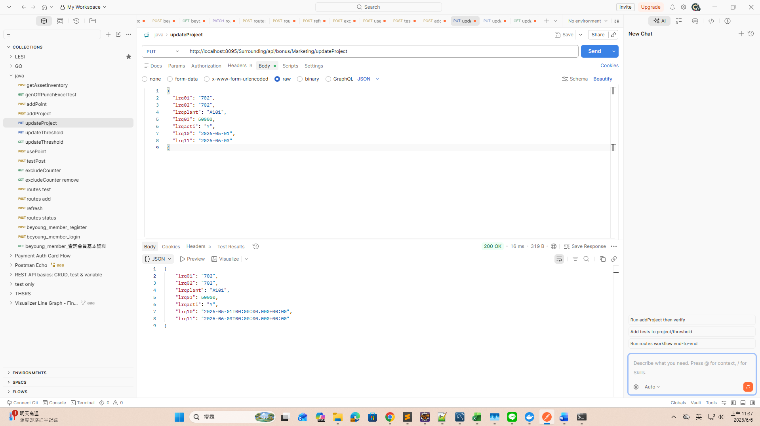

預期結果：回傳 HTTP 200 OK，回傳的實體中 `lrq03` 為 50000;
檢視 MySQL：SELECT lrq03 FROM lrq_file WHERE lrq01='702' AND lrq02='702' AND lrqplant='A101'; 欄位值已變更為 50000;
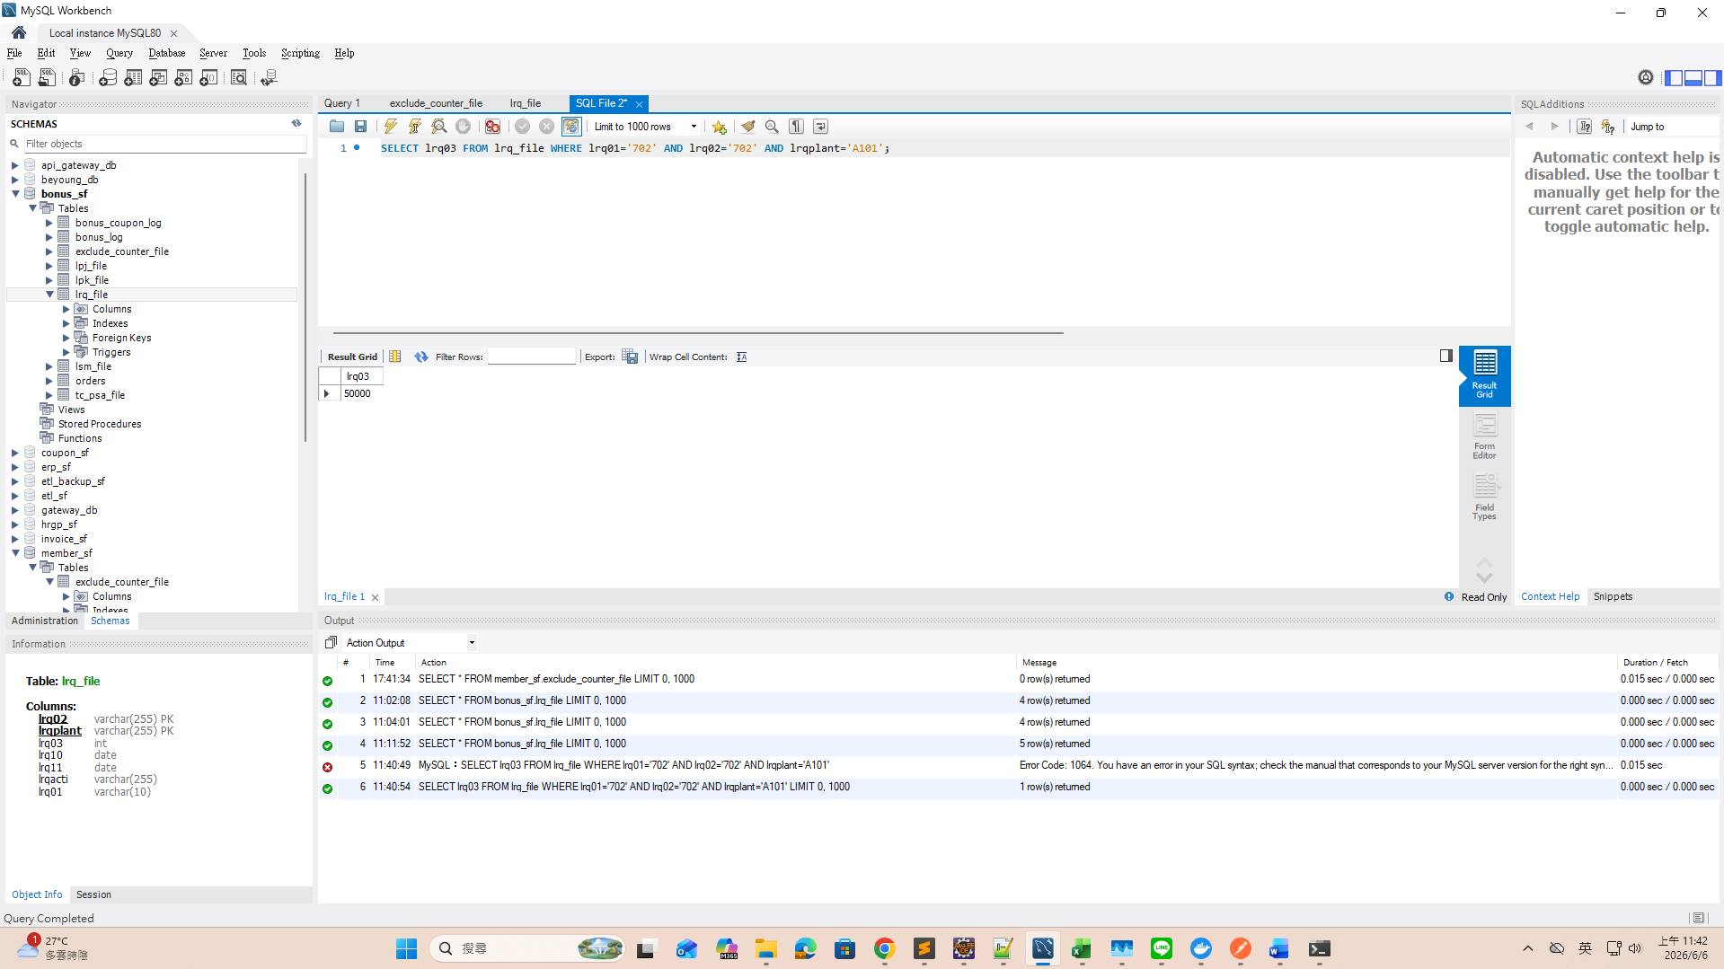

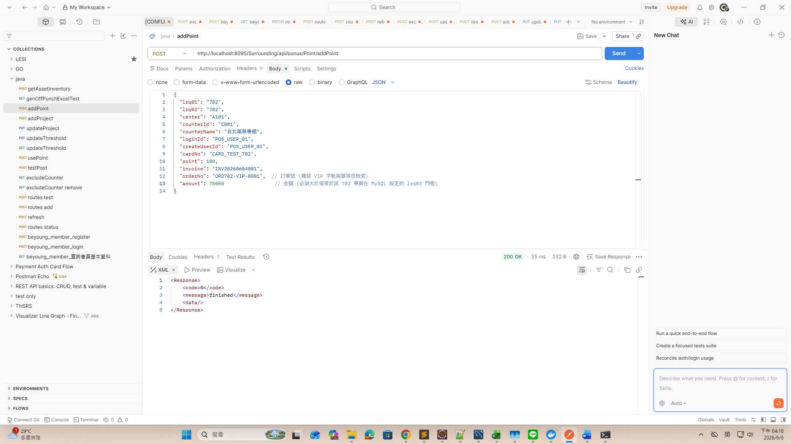
POST
http://localhost:8095/Surrounding/api/bonus/Point/addPoint
JSON
{
"lrq01": "702",
"lrq02": "702",
"center": "A101",
"counterId": "C001",
"counterName": "台北萬華專櫃",
"loginId": "POS_USER_01",
"createUserId": "POS_USER_01",
"cardNo": "CARD_TEST_702",
"point": 100,
"invoice": "INV20260604001",
"orderNo": "ORD702-VIP-0001", // 訂單號 (觸發 VIP 字軌與冪等性檢查)
"amount": 75000 // 金額 (必須大於或等於該 702 專案在 MySQL 設定的 lrq03 門檻)
}

LOG
[2m2026-06-06T16:17:15.155+08:00[0;39m [32m INFO[0;39m [35m16032[0;39m [2m--- [beyoung-bonus] [omcat-handler-1] [0;39m[36mcom.beyoung.bonus.api.BonusController [0;39m [2m:[0;39m Bonus：偵測到 VIP 贈點條件，卡號: CARD_TEST_702, 金額: 75000
Hibernate: select bl1_0.id from bonus_log bl1_0 where bl1_0.access_id=? limit ?
[2m2026-06-06T16:17:15.160+08:00[0;39m [32m INFO[0;39m [35m16032[0;39m [2m--- [beyoung-bonus] [omcat-handler-1] [0;39m[36mc.b.bonus.application.BonusService [0;39m [2m:[0;39m [VIP核心] 開始執行贈點事務落庫，AccessId: POS_VIP_1780733835155, 點數: 100
Hibernate: insert into bonus_log (access_date,access_id,card_no,center,counter_id,expiry_date,point,user_id,user_name) values (?,?,?,?,?,?,?,?,?)
Hibernate: select lf1_0.lsm01,lf1_0.lsm02,lf1_0.lsm03,lf1_0.lsm04,lf1_0.lsm05,lf1_0.lsm06,lf1_0.lsm08,lf1_0.lsm09,lf1_0.lsm10,lf1_0.lsm11,lf1_0.lsm12,lf1_0.lsm13,lf1_0.lsm15,lf1_0.lsmlegal,lf1_0.lsmplant,lf1_0.lsmstore,lf1_0.ta_lsm01,lf1_0.ta_lsm02,lf1_0.ta_lsm03,lf1_0.ta_lsm04,lf1_0.ta_lsm05,lf1_0.ta_lsm06,lf1_0.ta_lsm07,lf1_0.ta_lsm08,lf1_0.ta_lsm12,lf1_0.ta_lsm13 from lsm_file lf1_0 where (lf1_0.lsm01,lf1_0.lsm02,lf1_0.lsm03) in ((?,?,?))
[2m2026-06-06T16:17:15.171+08:00[0;39m [32m INFO[0;39m [35m16032[0;39m [2m--- [beyoung-bonus] [omcat-handler-1] [0;39m[36mc.b.bonus.application.BonusService [0;39m [2m:[0;39m [VIP核心] 滿額加贈 500 點完成，已成功發送非同步事件。

[2m2026-06-06T16:29:01.658+08:00[0;39m [32m INFO[0;39m [35m4092[0;39m [2m--- [beyoung-member] [pool-7-thread-1] [0;39m[36mo.a.k.c.t.i.KafkaMetricsCollector [0;39m [2m:[0;39m initializing Kafka metrics collector
[2m2026-06-06T16:29:01.670+08:00[0;39m [32m INFO[0;39m [35m4092[0;39m [2m--- [beyoung-member] [pool-7-thread-1] [0;39m[36mo.a.kafka.common.utils.AppInfoParser [0;39m [2m:[0;39m Kafka version: 3.8.1
[2m2026-06-06T16:29:01.670+08:00[0;39m [32m INFO[0;39m [35m4092[0;39m [2m--- [beyoung-member] [pool-7-thread-1] [0;39m[36mo.a.kafka.common.utils.AppInfoParser [0;39m [2m:[0;39m Kafka commitId: 70d6ff42debf7e17
[2m2026-06-06T16:29:01.670+08:00[0;39m [32m INFO[0;39m [35m4092[0;39m [2m--- [beyoung-member] [pool-7-thread-1] [0;39m[36mo.a.kafka.common.utils.AppInfoParser [0;39m [2m:[0;39m Kafka startTimeMs: 1780734541670
[2m2026-06-06T16:29:01.693+08:00[0;39m [32m INFO[0;39m [35m4092[0;39m [2m--- [beyoung-member] [pool-7-thread-1] [0;39m[36morg.apache.kafka.clients.Metadata [0;39m [2m:[0;39m [Consumer clientId=consumer-member-service-group-3, groupId=member-service-group] Cluster ID: tIBr3ym2TPuIZ8BopA--eA
[2m2026-06-06T16:29:01.729+08:00[0;39m [32m INFO[0;39m [35m4092[0;39m [2m--- [beyoung-member] [pool-7-thread-1] [0;39m[36mo.a.k.c.c.internals.ConsumerCoordinator [0;39m [2m:[0;39m [Consumer clientId=consumer-member-service-group-3, groupId=member-service-group] Discovered group coordinator localhost:9092 (id: 2147483646 rack: null)
[2m2026-06-06T16:29:03.717+08:00[0;39m [32m INFO[0;39m [35m4092[0;39m [2m--- [beyoung-member] [container-0-C-1] [0;39m[36mo.a.k.c.c.internals.ConsumerCoordinator [0;39m [2m:[0;39m [Consumer clientId=consumer-member-service-group-2, groupId=member-service-group] Successfully joined group with generation Generation{generationId=49, memberId='consumer-member-service-group-2-e6882498-941a-4480-b2af-439134880e4f', protocol='range'}
[2m2026-06-06T16:29:03.725+08:00[0;39m [32m INFO[0;39m [35m4092[0;39m [2m--- [beyoung-member] [container-0-C-1] [0;39m[36mo.a.k.c.c.internals.ConsumerCoordinator [0;39m [2m:[0;39m [Consumer clientId=consumer-member-service-group-2, groupId=member-service-group] Finished assignment for group at generation 49: {consumer-member-service-group-2-e6882498-941a-4480-b2af-439134880e4f=Assignment(partitions=[member-point-topic-0])}
[2m2026-06-06T16:29:03.734+08:00[0;39m [32m INFO[0;39m [35m4092[0;39m [2m--- [beyoung-member] [container-0-C-1] [0;39m[36mo.a.k.c.c.internals.ConsumerCoordinator [0;39m [2m:[0;39m [Consumer clientId=consumer-member-service-group-2, groupId=member-service-group] Successfully synced group in generation Generation{generationId=49, memberId='consumer-member-service-group-2-e6882498-941a-4480-b2af-439134880e4f', protocol='range'}
[2m2026-06-06T16:29:03.735+08:00[0;39m [32m INFO[0;39m [35m4092[0;39m [2m--- [beyoung-member] [container-0-C-1] [0;39m[36mo.a.k.c.c.internals.ConsumerCoordinator [0;39m [2m:[0;39m [Consumer clientId=consumer-member-service-group-2, groupId=member-service-group] Notifying assignor about the new Assignment(partitions=[member-point-topic-0])
[2m2026-06-06T16:29:03.739+08:00[0;39m [32m INFO[0;39m [35m4092[0;39m [2m--- [beyoung-member] [container-0-C-1] [0;39m[36mk.c.c.i.ConsumerRebalanceListenerInvoker[0;39m [2m:[0;39m [Consumer clientId=consumer-member-service-group-2, groupId=member-service-group] Adding newly assigned partitions: member-point-topic-0
[2m2026-06-06T16:29:03.751+08:00[0;39m [32m INFO[0;39m [35m4092[0;39m [2m--- [beyoung-member] [container-0-C-1] [0;39m[36mo.a.k.c.c.internals.ConsumerUtils [0;39m [2m:[0;39m Setting offset for partition member-point-topic-0 to the committed offset FetchPosition{offset=31, offsetEpoch=Optional.empty, currentLeader=LeaderAndEpoch{leader=Optional[localhost:9092 (id: 1 rack: null)], epoch=0}}
[2m2026-06-06T16:29:03.752+08:00[0;39m [32m INFO[0;39m [35m4092[0;39m [2m--- [beyoung-member] [container-0-C-1] [0;39m[36mo.s.c.s.b.k.KafkaMessageChannelBinder$2 [0;39m [2m:[0;39m member-service-group: partitions assigned: [member-point-topic-0]
[2m2026-06-06T16:29:09.661+08:00[0;39m [32m INFO[0;39m [35m4092[0;39m [2m--- [beyoung-member] [container-0-C-1] [0;39m[36mc.b.member.listener.MemberEventListener [0;39m [2m:[0;39m [Member服務]自 Kafka 接收到補點同步事件，卡號: CARD_TEST_702, 點數: +100.0
Hibernate: select lf1_0.lpj01,lf1_0.lpj09,lf1_0.lpj02,lf1_0.lpj03,lf1_0.lpj04,lf1_0.lpj06,lf1_0.lpj07,lf1_0.lpj08,lf1_0.lpj12,lf1_0.lpj13,lf1_0.lpj14,lf1_0.lpj15,lf1_0.lpj16,lf1_0.lpj17,lf1_0.lpj18,lf1_0.lpj19,lf1_0.lpjpos,lf1_0.ta_lpj01,lf1_0.ta_lpj02,lf1_0.ta_lpj03,lf1_0.ta_lpj04 from lpj_file lf1_0 where lf1_0.lpj03=?
Hibernate: select lf1_0.lpj01,lf1_0.lpj09,lf1_0.lpj02,lf1_0.lpj03,lf1_0.lpj04,lf1_0.lpj06,lf1_0.lpj07,lf1_0.lpj08,lf1_0.lpj12,lf1_0.lpj13,lf1_0.lpj14,lf1_0.lpj15,lf1_0.lpj16,lf1_0.lpj17,lf1_0.lpj18,lf1_0.lpj19,lf1_0.lpjpos,lf1_0.ta_lpj01,lf1_0.ta_lpj02,lf1_0.ta_lpj03,lf1_0.ta_lpj04 from lpj_file lf1_0 where (lf1_0.lpj01,lf1_0.lpj09) in ((?,?))
Hibernate: update lpj_file set lpj02=?,lpj03=?,lpj04=?,lpj06=?,lpj07=?,lpj08=?,lpj12=?,lpj13=?,lpj14=?,lpj15=?,lpj16=?,lpj17=?,lpj18=?,lpj19=?,lpjpos=?,ta_lpj01=?,ta_lpj02=?,ta_lpj03=?,ta_lpj04=? where lpj01=? and lpj09=?
[2m2026-06-06T16:29:09.934+08:00[0;39m [32m INFO[0;39m [35m4092[0;39m [2m--- [beyoung-member] [container-0-C-1] [0;39m[36mc.b.member.listener.MemberEventListener [0;39m [2m:[0;39m [Member服務]會員主檔已成功透過物件更新累計點數，卡號: CARD_TEST_702

[2m2026-06-06T16:47:23.170+08:00[0;39m [32m INFO[0;39m [35m4556[0;39m [2m--- [beyoung-bonus] [omcat-handler-1] [0;39m[36mcom.beyoung.bonus.api.BonusController [0;39m [2m:[0;39m Bonus：偵測到 VIP 贈點條件，卡號: CARD_TEST_702, 金額: 75000
[2m2026-06-06T16:47:23.171+08:00[0;39m [32m INFO[0;39m [35m4556[0;39m [2m--- [beyoung-bonus] [omcat-handler-1] [0;39m[36mc.b.bonus.application.BonusService [0;39m [2m:[0;39m //dc- [Debug] 檢查點：接收到的點數為: 100, 存入流水帳前的點數為: 100.0
Hibernate: select bl1_0.id from bonus_log bl1_0 where bl1_0.access_id=? limit ?
[2m2026-06-06T16:47:23.174+08:00[0;39m [32m INFO[0;39m [35m4556[0;39m [2m--- [beyoung-bonus] [omcat-handler-1] [0;39m[36mc.b.bonus.application.BonusService [0;39m [2m:[0;39m [VIP核心] 開始執行贈點事務落庫，AccessId: POS_VIP_1780735643170, 點數: 100
[2m2026-06-06T16:47:23.174+08:00[0;39m [32m INFO[0;39m [35m4556[0;39m [2m--- [beyoung-bonus] [omcat-handler-1] [0;39m[36mc.b.bonus.application.BonusService [0;39m [2m:[0;39m //dc- [Debug] 準備儲存的 BonusLog 物件點數為: 100
Hibernate: insert into bonus_log (access_date,access_id,card_no,center,counter_id,expiry_date,point,user_id,user_name) values (?,?,?,?,?,?,?,?,?)
[2m2026-06-06T16:47:23.176+08:00[0;39m [32m INFO[0;39m [35m4556[0;39m [2m--- [beyoung-bonus] [omcat-handler-1] [0;39m[36mc.b.bonus.application.BonusService [0;39m [2m:[0;39m [Debug] 已對資料庫執行 Flush 操作
Hibernate: select lf1_0.lsm01,lf1_0.lsm02,lf1_0.lsm03,lf1_0.lsm04,lf1_0.lsm05,lf1_0.lsm06,lf1_0.lsm08,lf1_0.lsm09,lf1_0.lsm10,lf1_0.lsm11,lf1_0.lsm12,lf1_0.lsm13,lf1_0.lsm15,lf1_0.lsmlegal,lf1_0.lsmplant,lf1_0.lsmstore,lf1_0.ta_lsm01,lf1_0.ta_lsm02,lf1_0.ta_lsm03,lf1_0.ta_lsm04,lf1_0.ta_lsm05,lf1_0.ta_lsm06,lf1_0.ta_lsm07,lf1_0.ta_lsm08,lf1_0.ta_lsm12,lf1_0.ta_lsm13 from lsm_file lf1_0 where (lf1_0.lsm01,lf1_0.lsm02,lf1_0.lsm03) in ((?,?,?))
[2m2026-06-06T16:47:23.183+08:00[0;39m [32m INFO[0;39m [35m4556[0;39m [2m--- [beyoung-bonus] [omcat-handler-1] [0;39m[36mc.b.bonus.application.BonusService [0;39m [2m:[0;39m [VIP核心] 滿額加贈 500 點完成，已成功發送非同步事件。

